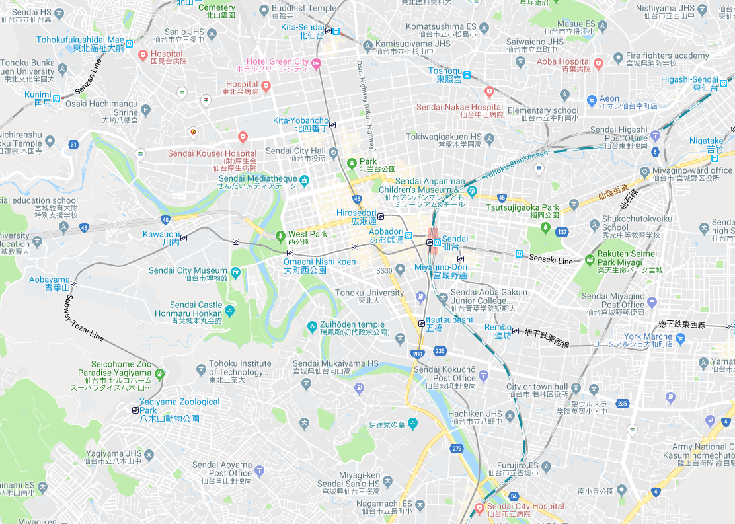

IH Higashi-

Sendai

Katahira Campus

UH Aobayama AAobayama

UH Katahira

UH Nagamachi

Kawauchi Campus

UH Sanjo,Ⅱ,Ⅲ,

IH Sanjo

IH Sanjo2 2

Aobayama Campus

Seiryo Campus