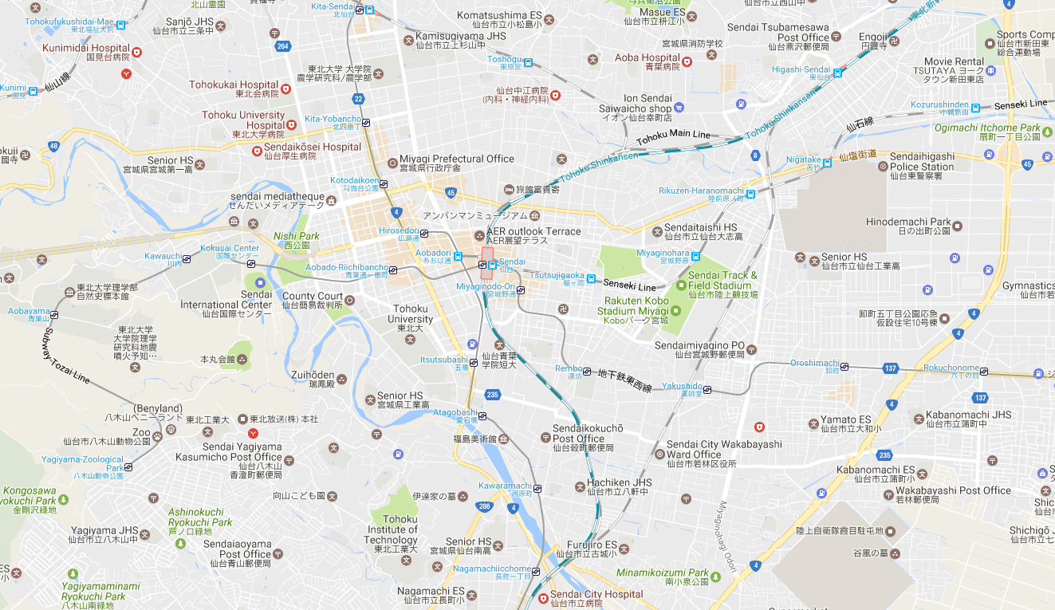

IH Sanjo1・  
UH SanjoⅠ・Ⅱ・Ⅲ

UH Nagamachi

Aobayama Campus

Kawauchi Campus

Katahira Campus

UH Katahira

IH Higashisendai

Seiryo Campus

IH Sanjo2

かかかか